Lab assignment- 1
ID:2303A51940
TASK-1
Install and configure GitHub Copilot in VS Code. Take screenshots of each step.
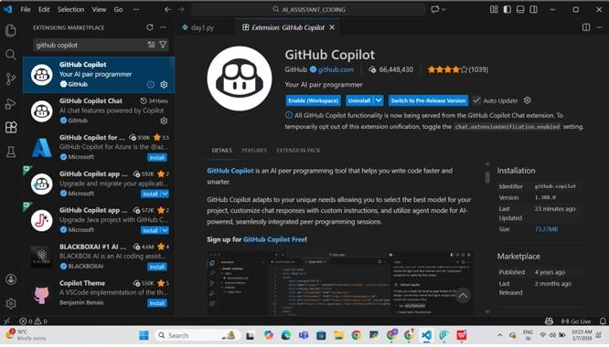
Task 1: AI-Generated Logic Without Modularization (Factorial without Functions)
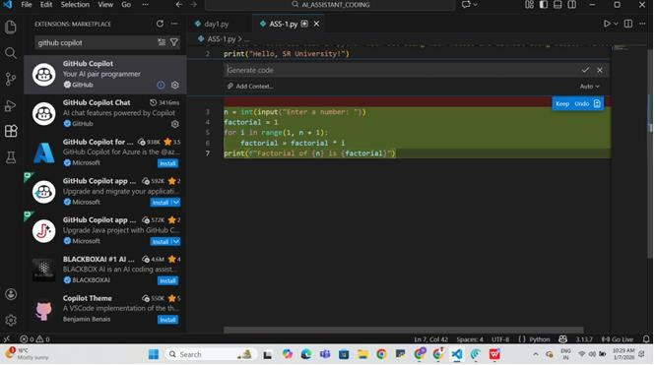

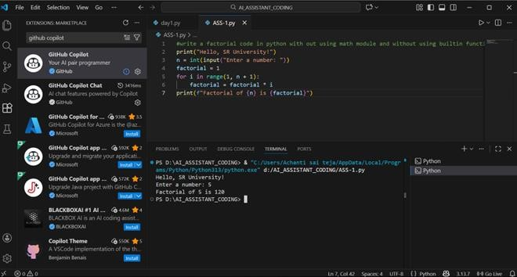
The program takes a number from the user as input. It uses a loop to multiply numbers from 1 to the given number. The result of this multiplication gives the factorial value. Finally, it prints the factorial of the entered number. Howhelpful was Copilot for a beginner? Copilot is very helpful for a beginner because it quickly suggests correct and readable code, reducing the time needed to think about syntax. It makes learning easier by providing a working structure, like loops and variable initialization, as seen in the factorial program. Did it follow best practices automatically? Copilot generally follows best practices such as clear variable names and simple logic flow. However, beginners still need to understand the code instead of blindly accepting suggestions. It may not always handle edge cases (like negative numbers) unless explicitly prompted. Overall, Copilot is a strong learning aid but not a replacement for conceptual understanding. Task 2: AI Code Optimization & Cleanup (Improving Efficiency)
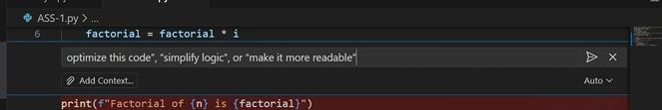
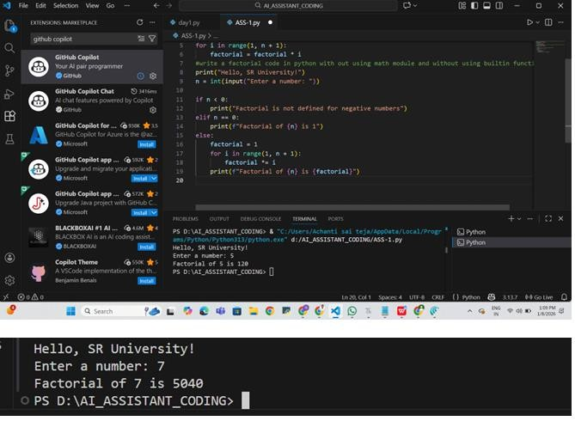
What wasimproved? Added proper input validation to handle negative numbers and the special case of 0. Removed duplicate code and structured the program with clear conditional branches. Ensured the program prints the final result in all valid cases. Improved clarity and flow of the logic. Whythenewversion is better (readability, performance, maintainability)? Readability: Clear if–elif– else structure makes the logic easy to understand. Performance: Avoids unnecessary calculations for invalid or zero inputs. Maintainability: Well-organized conditions make future changes or enhancements easier. Reliability: Handles edge cases correctly, reducing runtime errors. Task 3:
Modular Design Using AI Assistance (Factorial with Functions)
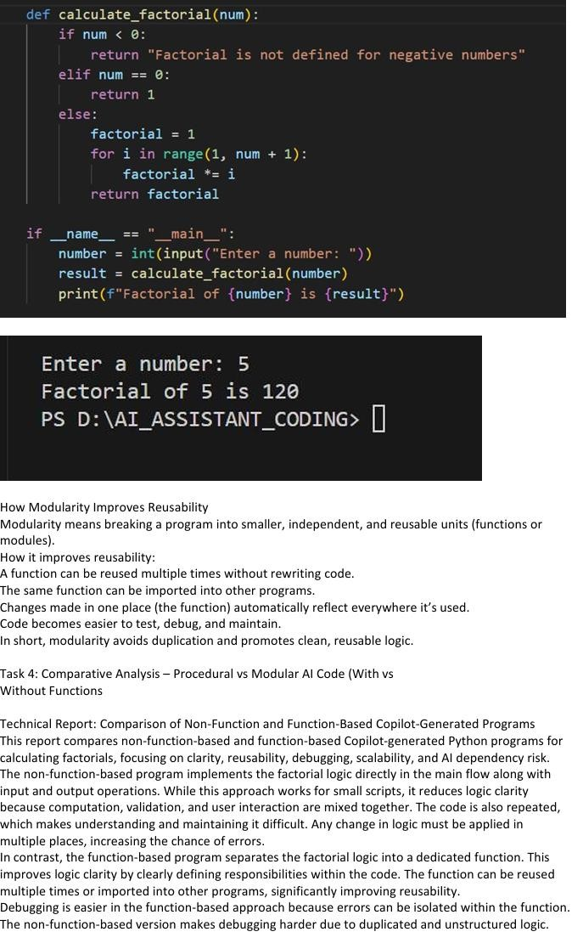
For large projects, non-function-based code does not scale well, whereas function-based code supports modularity, testing, and teamwork. Finally, AI dependency risk is higher in non-functionbased programs, as repeated AI-generated code may introduce redundancy and inconsistencies. Function-based code minimizes this risk by promoting standardized and reusable logic. Overall, function-based programs are more reliable, maintainable, and suitable for long-term development. Task 5: AI-Generated Iterative vs Recursive Thinking Iterative model

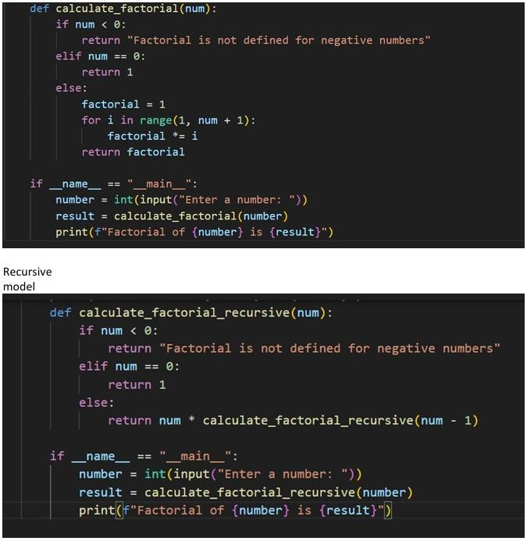
Below is a clear execution flow explanation and comparison of the two AI-generated
implementations (Iterative and Recursive factorial). Execution Flow Explanation Iterative Model The program takes an integer input from the user. The calculate_factorial(num) function checks: If the number is negative → returns an error message. If the number is 0 → returns 1. For positive numbers, a loop runs from 1 to num. The factorial value is updated step by step using multiplication. The final result is returned and printed. Flow: Input → Loop-based multiplication → Outpu Recursive Model The program takes an integer input from the user. The calculate_factorial_recursive(num) function checks: If the number is negative → returns an error message. If the number is 0 → returns 1 (base case). For positive numbers, the function calls itself with num- 1. Recursive calls continue until the base case is reached. Results are multiplied while returning back through the call stack. Flow: Input → Repeated function calls → Base case → Backtracking → Output Comparison Readability Iterative: More straightforward and easier for beginners to understand. Recursive: Shorter and mathematically elegant, but harder to trace. Stack Usage Iterative: Uses constant memory (no call stack growth). Recursive: Uses stack memory for each function call. Performance Implications Iterative: Faster and more memory-efficient. Recursive: Slightly slower due to function call overhead. WhenRecursion Is Not Recommended Wheninput size is large (risk of stack overflow). Whenperformance and memory efficiency are critical. In environments with limited stack memory

